**THE ROLE OF INFORMATION AND COMMUNICATION TECHNOLOGIES IN SHAPING SOCIAL BEHAVIOR AND ECONOMIC DEVELOPMENT.**

**Nana Akwasi Owusu**

**Lawrence Owusu**

**Joseph Twum-Boateng**

**ABSTRACT**

*Information and Communication Technologies have risen over the years to become an indispensable part of humanity in this 21st century. This research paper seeks to delve into the different roles Information and Communication Technologies have and are continuing to play in shaping social behavior and the impact they are having on economic development. It explores the influence of digital communication tools such as social media on human interactions, and also the impact of modern technologies on social behavior. The results prove that ICTs have significantly improved social connectivity and collaboration and have also contributed to advances in the economy through increase in productivity and efficiency. Nevertheless, negative impacts were found to be associated with ICTs which include privacy and cyber issues, job displacement due to advancement in Artificial Intelligence, and digital inequality. The findings go on to suggest that in as much as ICT has advanced economic development, there has to be strategic laws and policies to guide its integration so that we get a sustainable environment. Hence, policy makers and stakeholders must act responsibly to take crucial decisions so that technology can be leveraged effectively.*

*Keywords: Information and Communication Technologies, productivity, Artificial intelligence, digital inequality, social behavior, cyber issues*

**INTRODUCTION**

Information and Communication Technologies (ICTs) have gradually become an irreplaceable asset in societies of this 21st Century which is revamping how individuals interact, work, and access opportunities. ICTs have accelerated globalization through the usage and deployment of social media platforms, artificial intelligence (AI)- driven automation and so on, and these have enabled instant communication and fostered economic growth. According to ITU, in 2023, over 5.3 billion people, which accounts for around 66% of the world’s population, used and patronized the internet of which their broadband subscriptions surpassed 7.3 billion. This quick adoption has transformed social norms, economic systems, and governance frameworks. Nevertheless, ICTs have also presented their unique challenges some of which include digital inequality, cybersecurity vulnerabilities, job displacement due to AI, and privacy issues. This apprises us of the fact that the use and adoption of ICTs is like a dual-edged sword: it comes with its positives as well as its disadvantages.

Studies have shown that ICTs enhance social connectivity and economic productivity. Berman (2024) proclaims that ICTs have created a “network society” where digital interactions have gone beyond geographical barriers and obstacles. Per the World Bank, a country’s GDP can be boosted by 1.5% when they increase their ICT adoption. However, Filipenco argues that technology will lead to job displacement due to automation that would perform duties faster and more efficient than humans would. This study goes on to address the loopholes of this by diving into both the potential benefits of ICTs and the associated risks on social behavior and economic development.

**Objectives of the Study:**

1. To examine the influence of ICTs, particularly digital communication tools, on social behavior and economic development.
2. To access the contribution of ICTs to economic development through productivity and efficiency gains.
3. To identify challenges associated with ICT integration, including digital inequality, cybersecurity issues, and AI-driven job displacement.
4. To propose policy recommendations for sustainable ICT adoption.

**LITERATURE REVIEW**

1. **Previous Studies on ICT and Social Behavior**

* Research on how ICTs, particularly social media, have transformed human interactions.
* Research on the impact of ICTs on social norms and interpersonal relationships

According to studies, ICTs have transformed social interactions among humans across the globe, particularly through the use of social media. Social media has changed the speed at which people communicate and has also altered what people say to each other as they fit it into as few characters as possible. You can talk to your favorite celebrity, make friends from across the world, spark social and political movements, and share your every thought due to social media, which was not possible in the past. Social media has also changed the way we communicate and how we do it. It has given us the platform to communicate across geography, cultures, and languages and this has created an interconnected community. According to Esteban, averagely 90% of young adults in OECD countries use social media actively every day.

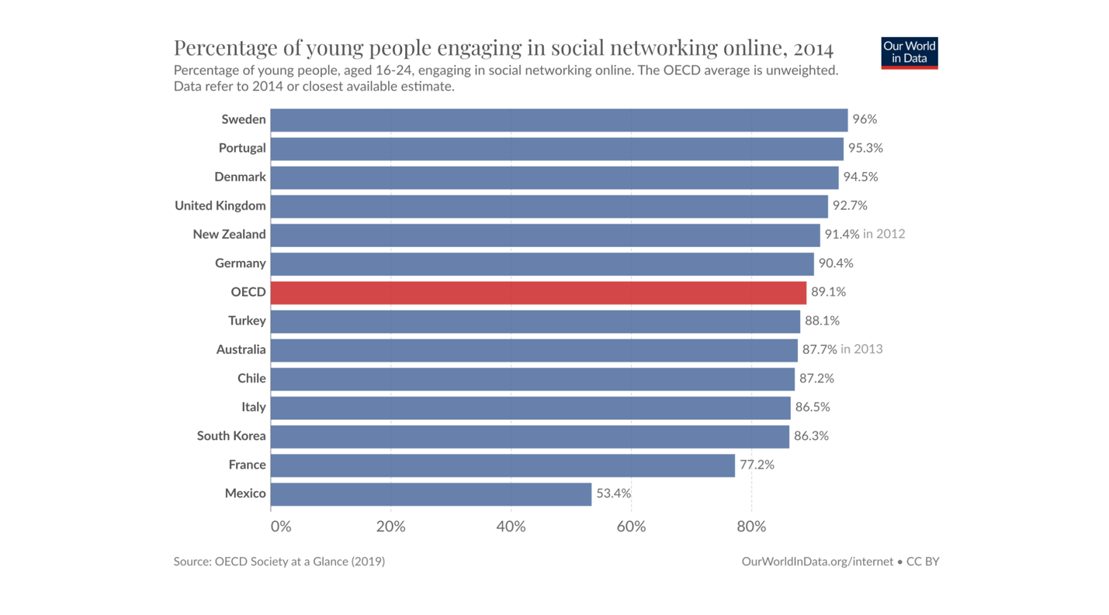

Due to the implementation of ICTs in our everyday lives, we’ve been able to stay connected with people and our loved ones. It’s almost next to impossible to meet your friends and relatives every day in today’s world of increasing stress and workload. However, dropping a short text to ask about their day or reaching out to them are a few ways one can maintain a healthy contact with close ones or relatives. Social media has transformed and effectively bridged this communication gap. Moreover, platforms such as Reddit and Discord host niche groups and this fosters collaboration. Ashley Stewart, a content marketing manager, reports that 64% of online community visitors say they’re visiting community sites more often than they did a couple of years ago. Language translation tools (e.g., Google Translate) and platforms like Tiktok have facilitated cultural exchange. All these go on to ratify how essential social media and ICTs at large have contributed to the interactions between people.

1. **Impact of ICT on Economic Development**

* Literature that discuss the role of ICTs in economic development, focusing on productivity, efficiency, and the overall economy.
* Studies that suggest ICT adoption leads to growth in GDP and other economic indicators.

Information and Communication Technologies (ICTs) have been instrumental in driving modern economic development which enables productivity, improves innovation, and bridges the global market. This section seeks to go into the different roles of ICTs in economic systems and we’ve supported it with empirical evidence, case studies, and insights. ICTs have enhanced productivity and efficiency through the use of AI automation. The biggest way technology can improve productivity is through time-saving tools from the use of automation. By taking repetitive or mundane tasks out of the hands of employees, you can free them up to do more creative work. AI Automation can also help employees get their work done more quickly. Meredith Somers, a news writer at MIT Management Slogan School, reports that Generative AI can improve a highly skilled worker’s performance by nearly 40% compared with workers who don’t use it. Platforms such as Amazon and Alibaba have empowered SMEs to access global markets. Amazon made $12.9 billion in the United States just two days on its Prime Day 2023, according to Investopedia.

1. **Challenges Linked to ICT Adoption**

* Negative effects of ICTs, including digital inequality (access to technology based on region, wealth, etc.), cybersecurity vulnerabilities, and job displacement due to automation and AI.
* Studies that have critiqued the social, economic, and ethical concerns of ICT integration.

**EXPLAIN EACH OBJECTIVE AND THE ANSWER TO EACH QUESTION**

1. **Influence of ICTs on Social Behavior and Economic Development**

* Discuss how social media, the internet, and communication tools affect social interactions. Examples from real-life scenarios, surveys, or case studies.
* Cite any data, such as statistics on online communication, collaboration tools, or changes in work culture due to digital tools.

1. **Contribution of ICTs to Economic Development**

* Insights into how ICTs boost productivity in businesses, increase access to information, and help create new industries. (e.g., tech startups, e-commerce)
* Provide graphs, data on the impact of ICT adoption on GDP, or studies from the World Bank or other organizations.

1. **Challenges Associated with ICT Integration**

* Highlight the difficulties in achieving equal access to technology, data privacy concerns, and the impact of AI on jobs.
* Use examples like the digital divide, high-profile cybersecurity breaches, or examples of industries affected by automation (e.g., manufacturing).

1. **Proposing Policy Recommendations for Sustainable ICT Adoption**

* Discuss potential policies or frameworks that can be implemented to reduce the negative impact of ICTs. Consider data privacy laws, efforts to increase broadband access, or training programs for workers affected by automation.
* Reference current laws or proposals, such as GDPR in Europe or digital literacy programs in emerging economies.

**DISCUSSION**

* **Key Points:** Summarize the key findings, such as the positive contributions of ICTs to economic development and social connectivity, as well as the negative effects, such as job displacement and digital inequality.
* **Insights**: Reflect on what the research findings suggest about the future of ICTs and their role in society. Do the positive impacts outweigh the negative ones, or vice versa?
* **Debates and Future Directions**: Identify any debates that emerged from your research. For example, are governments and businesses doing enough to manage the negative aspects of ICT adoption? What areas of future research could improve understanding or mitigate the challenges?

**CONCLUSION**

* **Key Conclusion**: ICTs have profound effects on society, offering opportunities for growth and collaboration, while also creating challenges such as inequality and job displacement. Effective policies and responsible adoption are essential for a sustainable future.
* **Call to Action**: Emphasize the importance of policy makers acting to manage the risks while maximizing the benefits of ICT.

REFERENCES

“Global Internet Use continues to rise but disparities remain, especially in low-income regions” 27 Nov. 2024. <https://www.itu.int/en/mediacentre/Pages/PR-2024-11-27-facts-and-figures.aspx#:~:text=When%20computing%20estimates%20for%20Facts,cent%20of%20the%20world's%20population> Accessed 18 Feb. 2025

Cobos, Estefania V., Malasquez, Eduardo A. “Growth and Transformative Effects of ICT Adoption: A Survey” March 2023. <https://documents1.worldbank.org/curated/en/099554003092330716/pdf/IDU0d9338f7201a08048bb088650a4f928761e4b.pdf> Accessed 18 Feb. 2025.

Berman, Marc. “6 Remarkable Ways Technology is Breaking Geographical Barriers” 22 May. 2024. <https://programminginsider.com/6-remarkable-ways-technology-is-breaking-geographical-barriers/> Accessed 18 Feb. 2025

Filipenco, Daniel. “Technology’s impact on employment: benefits and drawbacks” 9 Jan. 2024. [https://www.developmentaid.org/news-stream/post/173022/technology-impact-on-employment Accessed 18 Feb. 2025](https://www.developmentaid.org/news-stream/post/173022/technology-impact-on-employment%20Accessed%2018%20Feb.%202025).

Ortiz-Ospina, Esteban. "The Rise of Social Media." Our World in Data, 18 Sept. 2019, <https://ourworldindata.org/rise-of-social-media>. Accessed 6 Mar. 2025.

Stewart, Ashly. "15+ Top Stats about Online Communities." Personify, <https://personifycorp.com/blog/stats-online-communities/>. Accessed 6 Mar. 2025.

Somers, Meredith. "How Generative AI Can Boost Highly Skilled Workers' Productivity." MIT Sloan School of Management, 19 Oct. 2023, <https://mitsloan.mit.edu/ideas-made-to-matter/how-generative-ai-can-boost-highly-skilled-workers-productivity>. Accessed 6 Mar. 2025.

Krishna, Mrinalini. "The Amazon Effect on the U.S. Economy." Investopedia, 27 Aug. 2023, <https://www.investopedia.com/insights/amazon-effect-us-economy/>. Accessed 6 Mar. 2025.